Task : 01:

Using python implements VADER rules-based classification algorithm to find the sentiments of different sentences.

import matplotlib.pyplot as plt

from vaderSentiment.vaderSentiment import SentimentIntensityAnalyzer

def analyze_sentiment():

    sid_obj = SentimentIntensityAnalyzer()

    sentence = input("Enter a sentence: ")

    sentiment_dict = sid_obj.polarity_scores(sentence)

    print("Overall sentiment dictionary is:", sentiment_dict)

    print("Sentence was rated as {:.2f}% Negative".format(sentiment_dict['neg']*100))

    print("Sentence was rated as {:.2f}% Neutral".format(sentiment_dict['neu']*100))

    print("Sentence was rated as {:.2f}% Positive".format(sentiment_dict['pos']*100))

    print("Sentence Overall Rated As ", end="")

    if sentiment_dict['compound'] >= 0.05:

        print("Positive")

    elif sentiment_dict['compound'] <= -0.05:

        print("Negative")

    else:

        print("Neutral")

    labels = ['Positive', 'Neutral', 'Negative']

    sizes = [sentiment_dict['pos'], sentiment_dict['neu'], sentiment_dict['neg']]

    colors = ['green', 'gold', 'red']

    explode = (0.1, 0, 0)

    plt.pie(sizes, explode=explode, labels=labels, colors=colors, autopct='%1.1f%%', shadow=True, startangle=140)

    plt.axis('equal')

    plt.title('Sentiment Analysis')

    plt.show()

if __name__ == "__main__":

    analyze_sentiment()

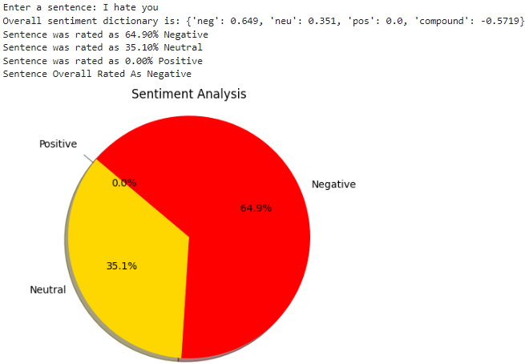

Task : 02 :Using python implements textBlob rules-based classification algorithm to find the sentiments of different sentences and compare the results with task # 01.

from textblob import TextBlob

def analyze_sentiment(sentence):

    blob = TextBlob(sentence)

    sentiment_polarity = blob.sentiment.polarity

    if sentiment_polarity > 0:

        sentiment = "Positive"

    elif sentiment_polarity < 0:

        sentiment = "Negative"

    else:

        sentiment = "Neutral"

    return sentiment

if __name__ == "__main__":

    sentence = input("Enter a sentence: ")

    sentiment = analyze_sentiment(sentence)

    print("Sentiment of the sentence '{}' is: {}".format(sentence, sentiment))

